**IDEATION PHASE**

**BRAINSTORM & IDEA PRIORITIZATION**

|  |  |
| --- | --- |
| **Team ID** | **PNT2022TMID13652** |
| **Project Name** | **Smart Waste Management System for Metropolitan Cities** |
| **Maximum Marks** | **4Marks** |

**STEP-1:**

**Team gathering ,Collaboration and select the problem statement**

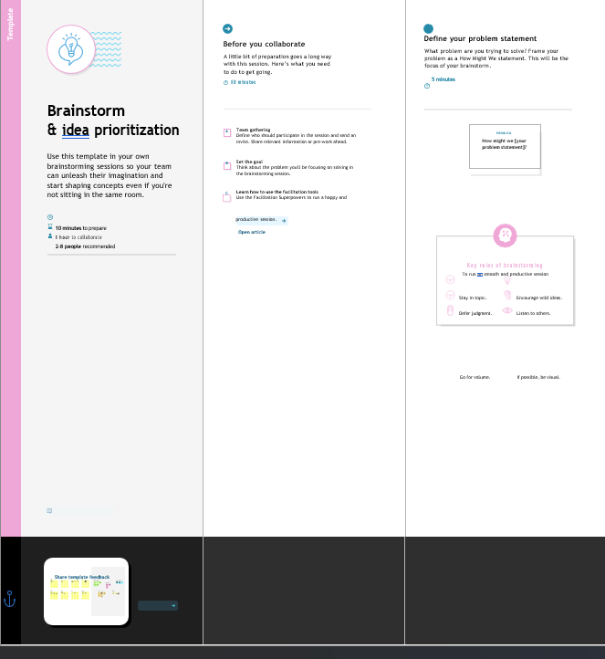

**STEP:2**

**Brainstorm, Idea, Listing and Grouping**

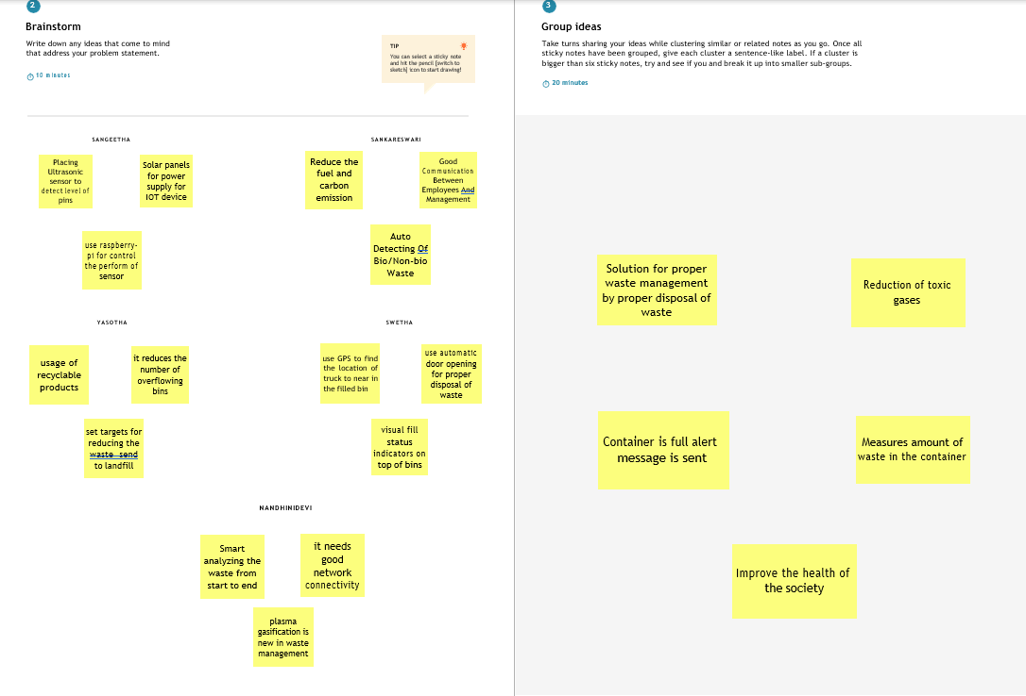

**STEP:3**

**Idea Prioritization**

